**INTRODUCTION:**

In the recent days, the process of being developing is drastically improved, particularly increased in the communication fields such as Bluetooth, other remote-controlled cars and robots. In every country technology is currently developing with many users, especially in India every people are using different operating systems which are available in several smart phones. In olden days the communication between devices should be transmitted in wired and risky way without seeking any help of any person. But in present world the communication between devices is improved in wireless manner without risk and fast are kept feasible manner with taking help of persons. Android operating system is used to communicate between Smartphone hardware and several mobile applications. This designed model is controlled with the help of Bluetooth using Smartphone. This robot is shaped like a car structure which contains of four wheels. This proposed designed is mainly used in different areas and fields in many industries Such as travelling goods from one place to another place and also moving many tiny particles in a fast manner. Arduino Uno is act as main controller of the device which controls Dc motors to move several directions. This model can control with two main devices. One device is computer and another device is our Smartphone. In many countries using of wheeled controlled robot cars are improved with increasing several industrial profits. To improve the performance of wheeled robots there are many developments available in all areas of life to develop in the world. All researchers are investigated the designed model extensively with the help remote.

L298n motor driver:

+12V → 9V battery (+)

GND → 9V battery (- ) and to arduino board any GND pin

In1 → arduino digital pin 7

In2 → arduino digital pin 6

In3 → arduino digital pin 5

In4 → arduino digital pin 4

OUT1 → Motor 1

OUT2 → Motor 1

OUT3 → Motor 2

OUT4 → Motor 2

HC-SR04 Ultrasonic Sonar sensor:  
VCC → +5V

Trig → arduino analog pin 1

Echo → arduino analog pin 2

GND → breadboard GND

HC-06 Bluetooth module:

VCC → +5V

GND → breadboard GND

TXD → arduino digital pin 0 (RX)

RXD → arduino digital pin 1 (TX)*[after going throught resistor connections]*

1. Install NewPing Library. (Ultrasonic sensor function library)
   * Download the NewPing.rar file
   * Unrar the file and copy NewPing file
   * Paste the file to Arduino libraries folder where you have installed the Arduino software in your PC (e.g:-*C:\Arduino\libraries*)
2. Download and open *bluetooth_obstacle_avoiding.ino*
3. Remove any connections made to arduino digital pin 0 (RX) and digital pin 1 (TX)
4. Upload the *bluetooth_obstacle_avoiding.ino* code
5. Make necessary connections to arduino digital pin 0 (RX) and digital pin 1 (TX) again

**REQUIREMENT ANALYSIS**

**Hardware Requirement Specification**

**Arduino UNO**

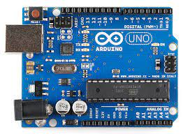Arduino name came from a bar in Ivrea which is located in Italy. Uno means one number in Italian language. Massimo Banzi was created Arduino Uno and Hernando Barragan was developed and added the support of microcontroller(atmega16) to wiring in 2003.It is easy to use and freely available in market with less cost. It also has a function that every user can develop without any problem. Arduino IDE software is used to handle this designed board easily with flexible manner. It is designed for to create engineering project and introduced in 2008 in the world. It consists of microcontroller (At mega 328p) to program the Arduino board using Arduino IDE software. It has a capacity to operate the output voltage 3.3 to 5v without any disturbances. Uno receive the voltage 7volts to 20volts as an input voltage.6 analog (pulse width modulation) pins and 14 digital pins is used to write and read the functions in the Arduino board. So here to transmit the serial data from Arduino board to projects Tx pin is used and also Rx pin is used to receive the serial data from project to Arduino board. Here mainly Arduino Uno board is used to control the overall designed model including each and every part

**Motor Driver L293D:**

To control two dc motors at the same time here two H-Ground motors is used which gives permissions to DC motors. L293d has H- bridge module which allows to control every direction of dc motors and speed. Here enables line is used to turn on and turn off the speed of all motors and motor drivers. It has 4 output pins and 4 input pins to control the motors independently and easily without any interruptions. Here TTL logic levels is designed to undertake heavy loads. L293d motor driver can handle the voltages from 5volts to 35volts easily and freely. To run the DC motors in any voltages motor driver can help to motors to convert low voltages to high voltages without any disturbances.

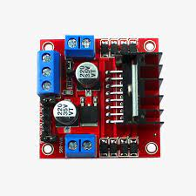

**Software:**

**Bluetooth RC Car/Arduino IDE**

It is designed for to control small type of robot car easily and also designed for small type of Iot devices ecofriendly. To store the data and to perform many several tasks this software application is used and also it helps very eco-friendly. To download this RC car application, it is freely available in Google Play store and Apple Appstore easily. To communicate with this designed model Bluetooth RC car application provides understandable interfaces to each and every user. This application is very fast to communicate with our designed model when compared to other applications and also it helpful to develop this esigned model in quick manner.

**Arduino Software:**

Micro controller is present in the Arduino pcb board which is used to communicate with this designed model easily and it is also used to control the whole Arduino board with flexible manner. To burnt the code in microcontroller IDE software is used. So here these coded instructions will be stored in EPROM with the help of Arduino IDE software.

**HC-05 Bluetooth Module:**

In 1994 started developing and designing of this board up to 1997 with a workable solution. Nils Rydbeck was developed radio technology in 1989 and after he named as Bluetooth at Ericsson Mobile in Lund Sweden. First Bluetooth was launched in the market in 1999. It is low cost and freely- available in the market. It is used to communicate with short range of devices with the help of bandwidth. Mainly it is used to replace the wired technology into wireless technology to design projects. It has 6 pins. Tx pin is used to transmit the data and Rx pin is used to receive the data and one pin is for ground pin and another pin is for Vcc. Rest two pins are key and state pins. It is connected and work in the range up to 100metres. It has lower power radio waves and also frequency band between 2.400GHZ to 2.483.5 GHZ to communicate with devices. It is also named as 2 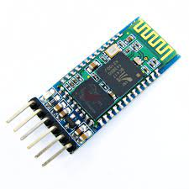slaved Bluetooth module for serial communications.

**ANALYSIS AND DESIGN**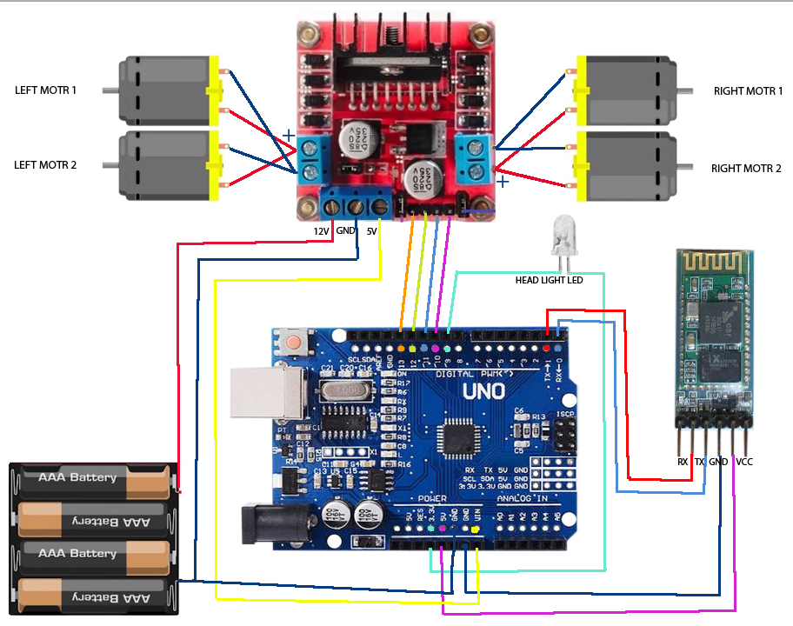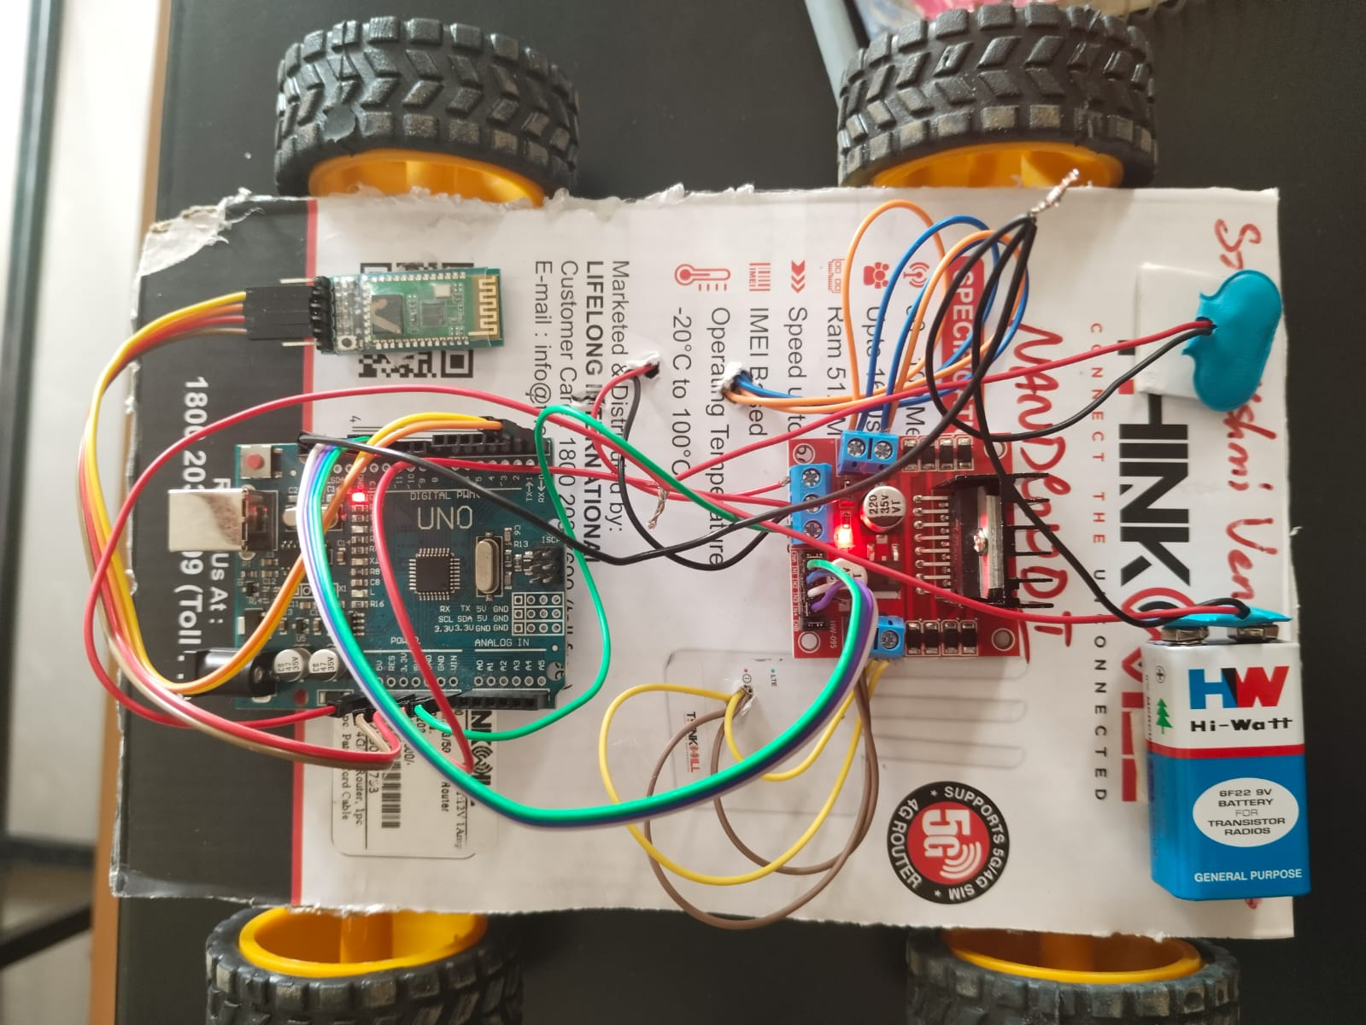

**IMPLEMENTATION**

char t;

void setup()

{

pinMode(13,OUTPUT); //left motors forward

pinMode(12,OUTPUT); //left motors reverse

pinMode(11,OUTPUT); //right motors forward

pinMode(10,OUTPUT); //right motors reverse

pinMode(9,OUTPUT); //Led

Serial.begin(9600);

}

void loop() {

if(Serial.available()){

t = Serial.read();

Serial.println(t);

}

if(t == 'F'){ //move forward(all motors rotate in forward direction)

digitalWrite(13,HIGH);

digitalWrite(11,HIGH);

}

else if(t == 'B'){ //move reverse (all motors rotate in reverse direction)

digitalWrite(12,HIGH);

digitalWrite(10,HIGH);

}

else if(t == 'L'){ //turn right (left side motors rotate in forward direction, right side motors doesn't rotate)

digitalWrite(11,HIGH);

}

else if(t == 'R'){ //turn left (right side motors rotate in forward direction, left side motors doesn't rotate)

digitalWrite(13,HIGH);

}

else if(t == 'W'){ //turn led on or off)

digitalWrite(9,HIGH);

}

else if(t == 'w'){

digitalWrite(9,LOW);

}

else if(t == 'S'){ //STOP (all motors stop)

digitalWrite(13,LOW);

digitalWrite(12,LOW);

digitalWrite(11,LOW);

digitalWrite(10,LOW);

}

delay(100);

}

**RESULTS:**

First time I designed this model successfully without any struggles in this paper. I kept the connections to the designed model according to the instructions which is given by me successfully. Finally, this designed model can move the several directions and also it can move the robot car from one place to another place. I have tested this designed model many times and many places it performing tasks according to our requirements without any problems. I have designed this model to control user in longdistances with the help of Bluetooth.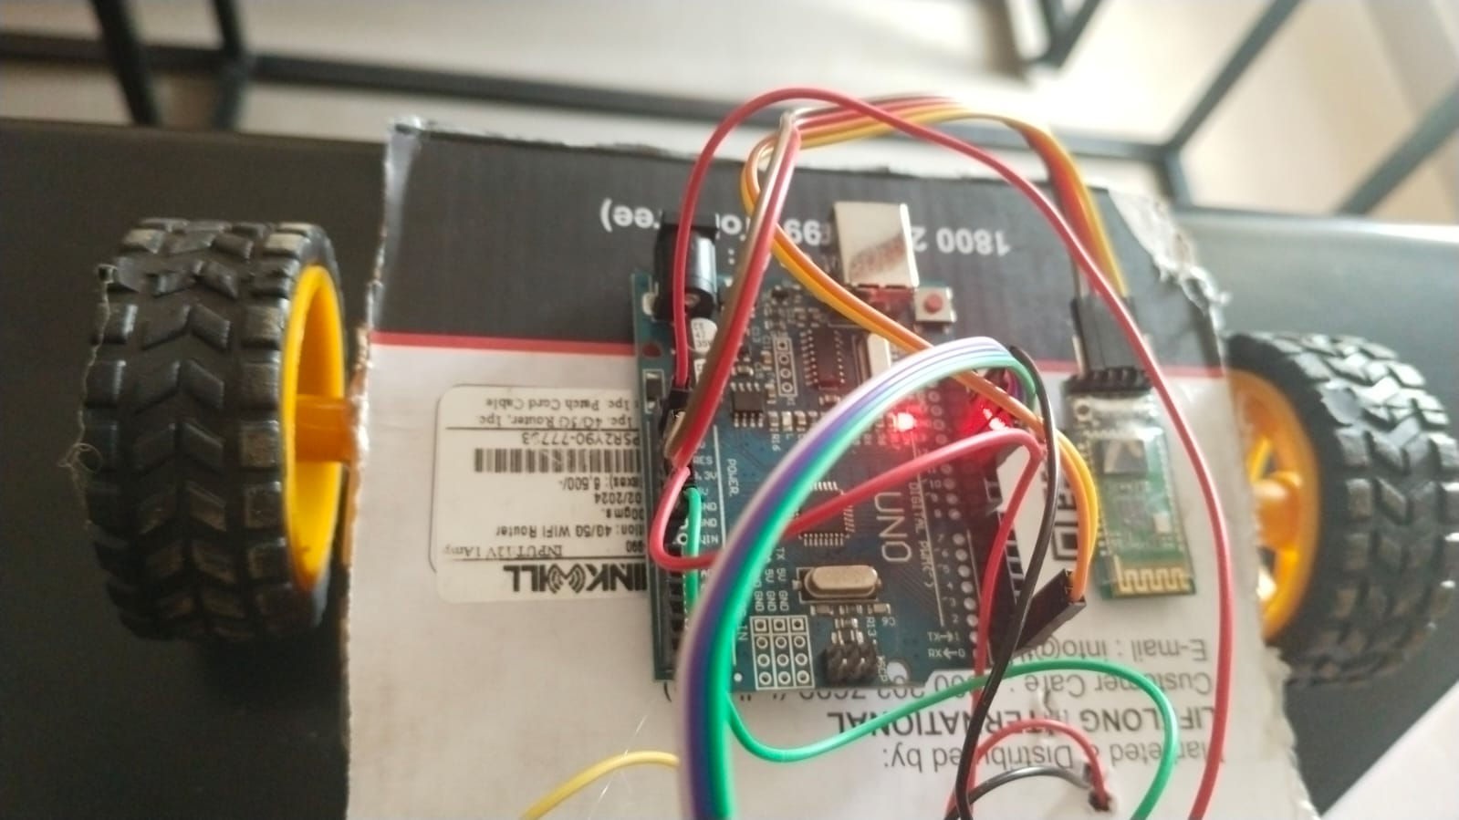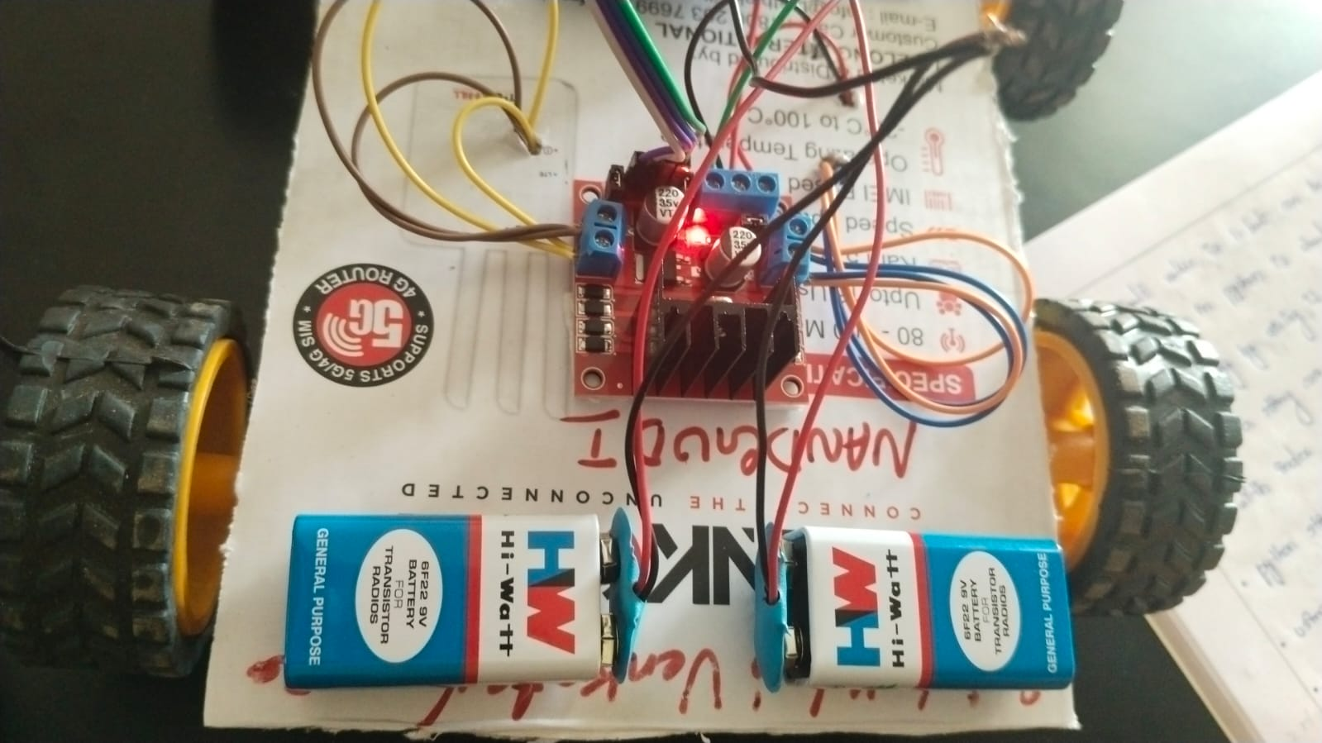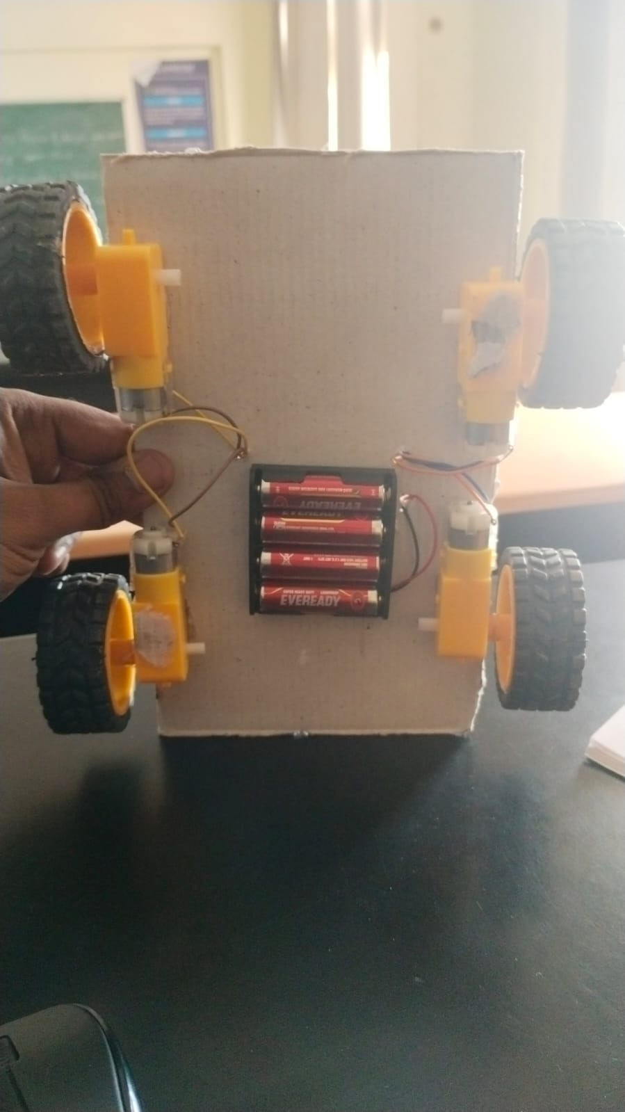

**ADVANTAGES:**

The product is both simple and inexpensive to put in place, Motion controlled, Multiple use, Easy to install, low cost, manually operated, Motion controlled, Multiple use.

**DISADVANTAGES:**

Results from humanoid robots will be that many people are going to lose their jobs.

**APPLICATIONS**

The rear side motor is utilized to propel the vehicle forward and backward. A Bluetooth module is utilized to receive commands from an Android smartphone, while an Arduino UNO controls the entire system. Mobile Low-Range Surveillance Equipment, Défense Applications (no human intervention), Assistive technology (like wheelchairs) , Home automation. controlling the robot easier so it can follow commands. His work demonstrates how different electrical gadgets may run the same android software. This project has industrial and military uses.

**FUTURE SCOPE**

According to my requirement I have designed this model successfully. So, to develop this model there are many problems are there to overcome this issue.

I have noticed that while saw the object while moving one place to another place. So, to overcome this issue add the camera is possible in future.

2ND thing I have noticed that while moving the robot car the range is very low to operate the carin long distance. To overcome the issue updated to the latest version of Bluetooth and increasethe design in future.

3rd thing I have noticed that while controlling the robot car remotely very tough in some cases. So, adding of Google Assistant is very easy to control in future scope.

**CONCLUSION:**

In this design, we used a Bluetooth Controller programmed from the Android Play Store to operate the robot with an Android phone. With the application installed, we could maneuver the robot in four directions. Upon clicking the "FORWARD ARROW" button, the data "Forward" is transmitted to the automobile, which then travels FORWARD. When the "BACKWARD ARROW" button is pressed, the data "Backward" is transmitted to the linked Bluetooth Module, and the vehicle goes BACKWARD. When the "LEFT ARROW" button is pressed, the data "Left" is transmitted to the linked Bluetooth Module, and the automobile turns LEFT. When the "RIGHT ARROW" button is pressed, the data "Right" is transmitted to the linked Bluetooth Module, and the automobile goes RIGHT. The project has achieved its goal of building an android interface, Arduino bot, and Arduino microprocessor code. The Arduino automobile is equipped with a microcontroller and basic mobility features. Arduino programmes provide instructions that serve as an intermediary between an Android controller and an Arduino automobile